EX.No. : 5

**SELECT with various clause – WHERE, pattern matching **

AIM:
To view the records from the Saveetha Hospital table using SELECT commands with WHERE clause and pattern matching.

DESCRIPTION:
The SELECT statement is used to retrieve data from a table. The WHERE clause filters rows according to a condition. Pattern matching is performed using the LIKE operator. The % wildcard matches zero or more characters and the _ wildcard matches one character.

SELECT:
SELECT column1, column2, ... FROM table_name WHERE condition;

LIKE:
SELECT * FROM table_name WHERE column_name LIKE 'pattern';
In MySQL, % matches any string of zero or more characters and _ matches any single character.

Saveetha Hospital Dataset:
patients(patient_name, ward, treatment, doctor, operation, operation_fee)

Questions:
1. The hospital administrator wanted to display the patient name, ward and treatment for all patients.
2. Display all patients who have undergone an operation.
3. List the patients whose treatment is 'Cancer'.
4. Display all patients whose operation fee is greater than 10000.
5. Display all patient details whose doctor is not 'Paracetamol'.
6. List the patients whose name ends with the substring 'sh'.
7. Display all patients whose name contains the substring 'sh'.
8. Find all patients whose doctor name contains 'par' as a substring.
9. Display the patients whose names do not contain exactly six letters.
10. Find all the patients whose names contain 'am'.

OUTPUTS:

1. The hospital administrator wanted to display the patient name, ward and treatment for all patients.
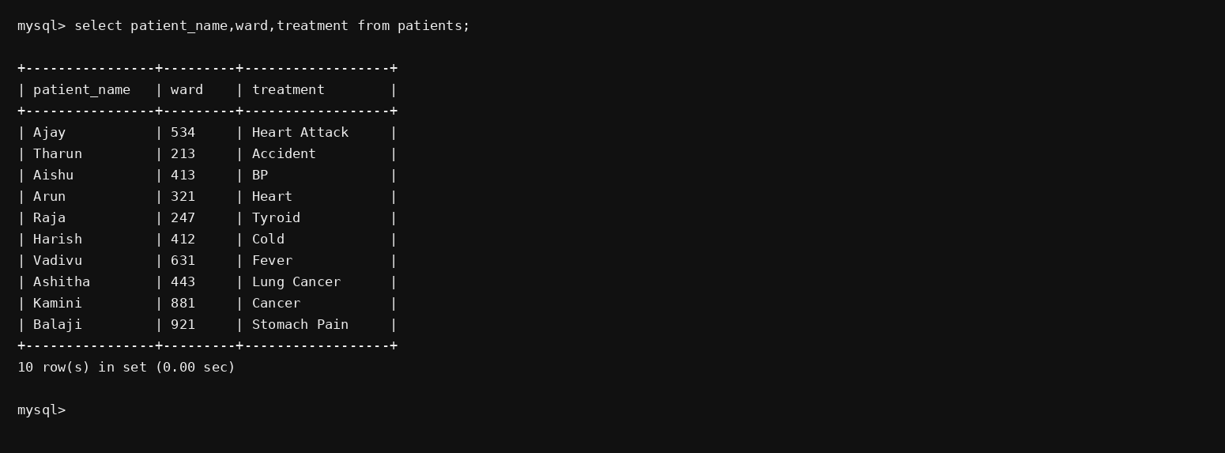

2. Display all patients who have undergone an operation.
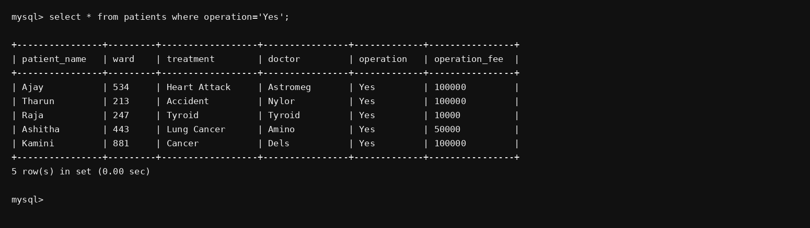

3. List the patients whose treatment is 'Cancer'.
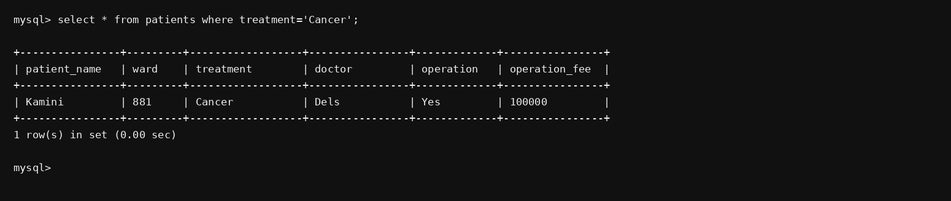

4. Display all patients whose operation fee is greater than 10000.
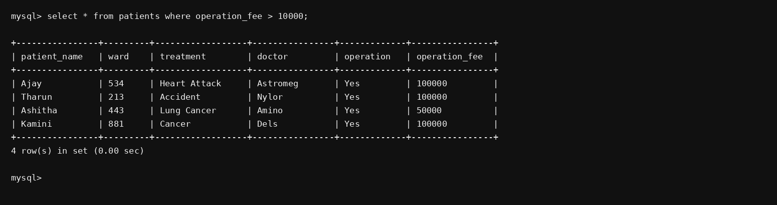

5. Display all patient details whose doctor is not 'Paracetamol'.
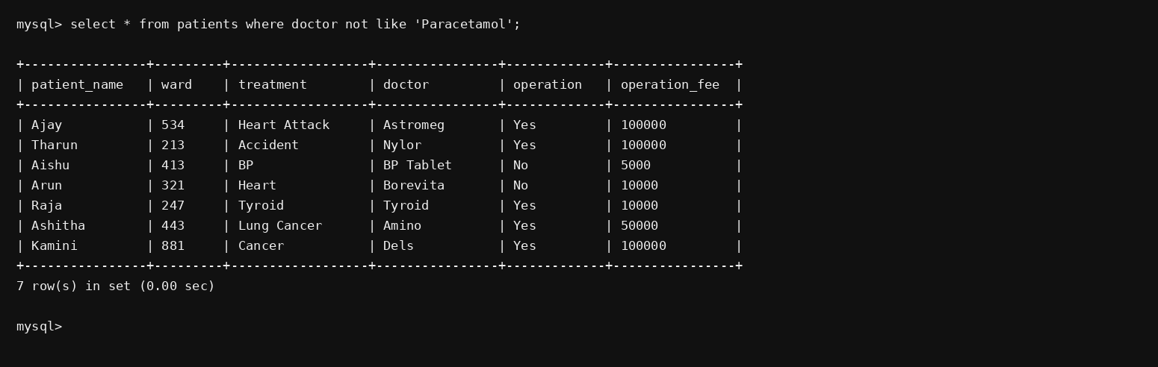

6. List the patients whose name ends with the substring 'sh'.
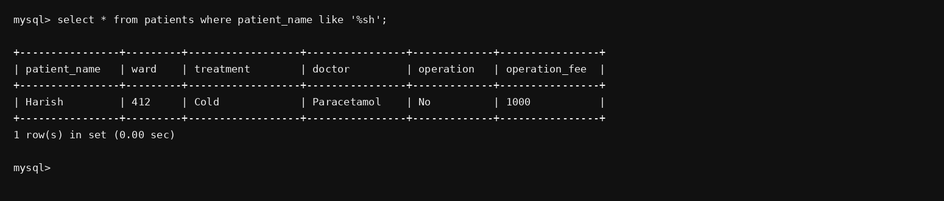

7. Display all patients whose name contains the substring 'sh'.
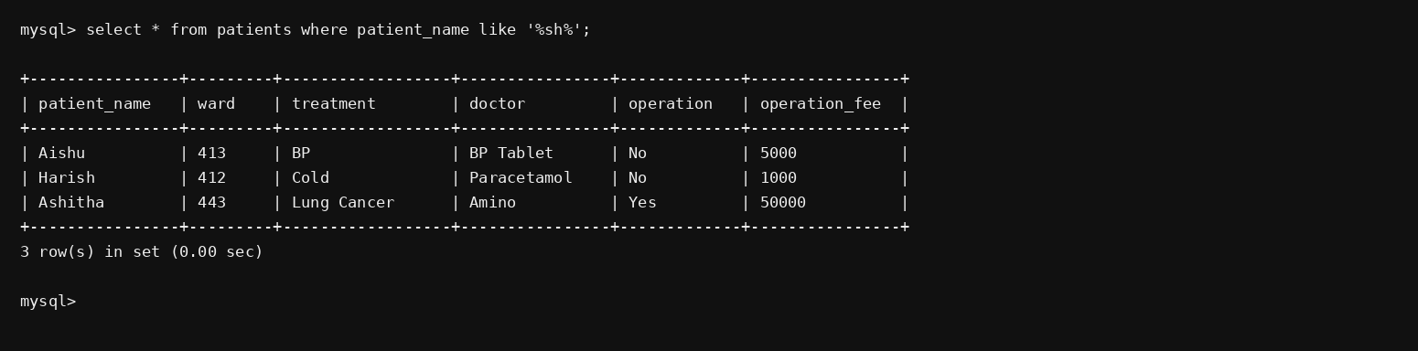

8. Find all patients whose doctor name contains 'par' as a substring.
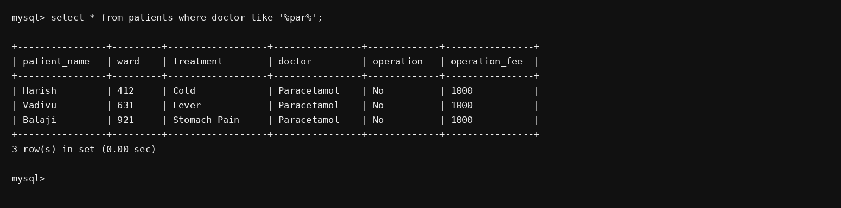

9. Display the patients whose names do not contain exactly six letters.
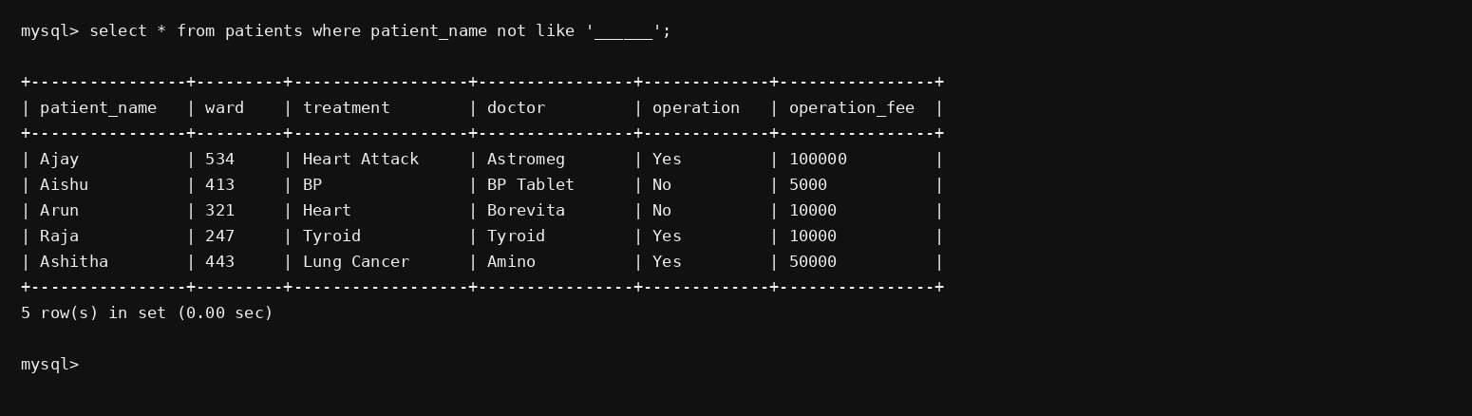

10. Find all the patients whose names contain 'am'.
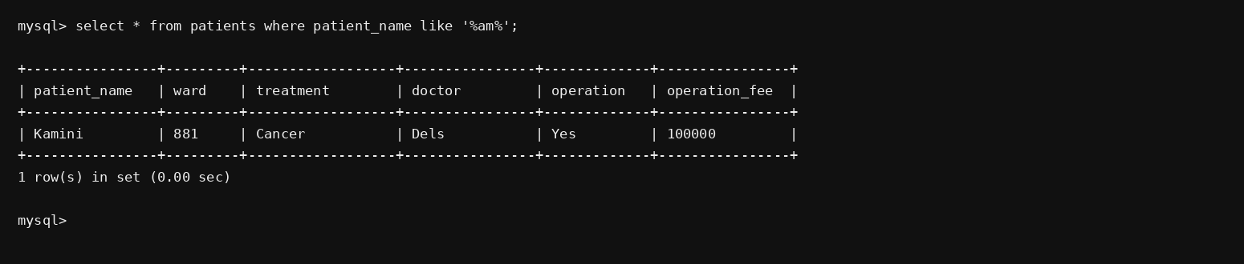

RESULT:
The records from the Saveetha Hospital table are successfully displayed using SELECT commands with WHERE clause and pattern matching.

